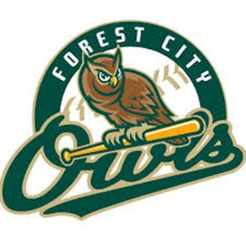
2023 Special Nights at the Ballpark
(subject to change)

May 29th Memorial Day Remembrance*
June 3rd Opening Night/AYCE/Fireworks
June 6th Faith Night*
June 10th Petting Zoo*
June 12th Cancer Night
June 15th Bark in the Park
June 17th AYCE
June 24th Touch-a-Truck
July 1st AYCE/Fireworks
July 3rd Fireworks (4th of July Celebration)
July 6th Ladies Night
July 7th Beerfest
July 10th Waffle House Night
July 15th AYCE/ATV Raffle
July 29th AYCE/Star Wars Night

*Chick-fil-A Food Truck

